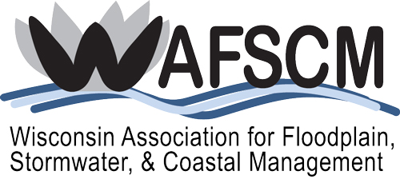

2025 WAFSCM Awards
APPLICATION
Key Dates and Deadlines
Submission Deadline: Postmarked by July 31, 2025
WAFSCM Judging August 1 through September 5, 2025
Entrants Notified of Awards September 8, 2025
WAFSCM Annual Meeting/Awards Luncheon October 16, 2025
Please submit either a completed paper copy or electronic copy of the application along with supporting documentation to Laura Herrick no later than July 31, 2025. Ms. Herrick’s contact information is as follows:
Laura K. Herrick
SEWRPC
P.O. Box 1607
Waukesha, WI 53187-1607
lherrick@sewrpc.org
Phone: 262-953-3224

WAFSCM AWARD 2025 APPLICATION FORM 1
Award (check one):
Chapter Service Award
Intended to recognize individuals who, through significant accomplishments and/or long-term efforts, have clearly influenced the work of the Association to improve floodplain, stormwater, or coastal management in Wisconsin.
Local Award for Excellence
Intended to recognize an individual, organization, program, governmental unit, or the like, which has contributed outstanding or essential work toward implementing sound flood plain, stormwater, or coastal management.
Excellence in Project Design or Implementation
Recognition focusing on particularly meritorious project efforts more so than individuals. Thereby, teams, firms, agency divisions, etc., may find a recognition niche.
Lifetime Achievement
For distinguished and extensive service, normally over the course of a career, toward advancing the cause and/or ideals of best practical floodplain, storm water, or coastal management.
Jimmy Award
Intended to recognize an individual or individuals for behind the scenes help and support of WAFSCM throughout the year.

Nominee (Individual name/s, agency/s or firm/s, etc.)
(Exactly as you would like to see printed on award)
Name
Title
Address
City/State/Zip
Phone
E-Mail
Nominator:

Project Information (for Excellence in Project Design or 2
Implementation Award only):
Project Name
Client/Owner
Project Location
Project Description

Project Primary Contact (for Excellence in Project Design or Implementation Award only):
Name
Title
Address
City/State/Zip
Phone
E-Mail
The primary contact is someone familiar with the project and able to answer questions about the project and/or entry. The primary contact will receive communication regarding the WAFSCM Project Awards competition, including the award notification, deadline reminders and Awards Luncheon information. Provide the following information for the project’s primary contact:

Why Nominee is Worthy of Special Recognition (All Awards):
Describe in layman’s terms why the nominee is worthy of special recognition. Judges have technical expertise, but may not be familiar with the area of expertise addressed in the entry. You may include additional pages, photos and/or illustrations, but please make sure to include captions for photos/illustrations.

