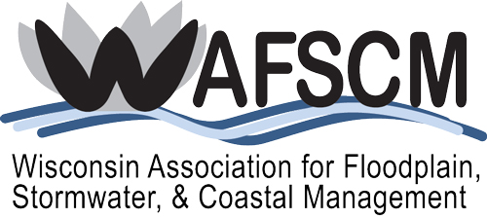

WAFSCM AWARD NOMINEES SOUGHT

WAFSCM is currently accepting nominations for awards to be presented at the 2025 conference to be held October 15-16 in Eau Claire, Wisconsin. You may nominate deserving parties for any of the five categories below. Self-nominations are accepted for the Excellence in Project Design or Implementation award.
- Chapter Service Award
- Local Award for Excellence
- Excellence in Project Design or Implementation Award
- Lifetime Achievement Award
- Jimmy Award
The WAFSCM Awards Program began in 2006 and the awards are described below:
The Chapter Service Award is intended to recognize individuals who, through significant accomplishments and/or long-term efforts, have clearly influenced the work of the Association to improve floodplain, stormwater, or coastal management in Wisconsin.
The Local Award for Excellence is intended to recognize an individual, organization, program, governmental unit, or the like, which has contributed outstanding or essential work toward implementing sound floodplain, stormwater, or coastal management.
Excellence in Project Design or Implementation is a means to provide recognition focusing on particularly meritorious project efforts more so than individuals. Thereby, teams, firms, agency divisions, etc., may find a recognition niche.
A Lifetime Achievement Award will also be entertained for distinguished and extensive service, normally over the course of a career, toward advancing the cause and/or ideals of best practical floodplain, stormwater, or coastal management. This prestigious award may be given as warranted. Please consider the credentials of deserving candidates for these awards!
The Jimmy Award is intended to recognize an individual or individuals for behind the scenes help and support of WAFSCM throughout the year. Both members and/or nonmembers are eligible for this award. 2014 marked the first year this award was given and was named after its first recipient – Jim DeBruine.
We have streamlined our process and have a nomination form requiring basic information including contact information, details on the nominee(s) with respect to merit and accomplishments, and the relationship or perspective of the nominator (knowledge of award-worthiness). Brief supporting materials are acceptable, but extensive documentation is discouraged. If appropriate, the Awards Committee may contact persons submitting nominations for additional information. The Awards Application form can be found on our website at www.wafscm.org.
Please submit your nomination for any of the above awards by July 31, 2025 to:
Laura Kletti Herrick
SEWRPC
P.O. Box 1607
Waukesha, WI 53187-1607
lherrick@sewrpc.org
262-953-3224

2025 Awards Request Letter.doc

