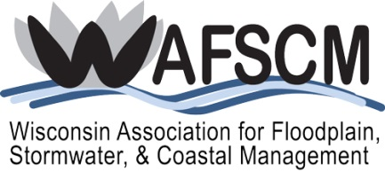
SCHOLARSHIP REIMBURSEMENT
for
ASFPM’S 47th Annual National Conference
May 7-11, 2023
Raleigh, North Carolina

Name:
Title:
Employer:
Address:
City/State/ZIP:
Phone:
Email:

This form must accompany all scholarship reimbursement requests for the ASFPM 2023 Annual Conference. Please complete form, attach receipts, and mail or email to the Wisconsin Association for Floodplain, Stormwater, & Coastal Management at the address below. Requests exceeding the approved scholarship amount will be adjusted. One check for all authorized expenses will be issued to you individually; you are responsible for reimbursing your employer for any expenses they may have paid. Reimbursement cannot be processed until all proper paperwork is received, verified, and approved. The due date is June 12, 2023.

REIMBURSEMENT CLASS | AUTHORIZED AMOUNT | REQUESTED AMOUNT | RECEIPT ATTACHED
REGISTRATION  Only early discount registration qualifies; late fees cannot be reimbursed. | ☐$725/$650 ASFPM  Member  ☐ $910/$835 Non-  Member
HOTEL/LODGING  $200 plus tax for a maximum of four nights. Hotel receipt must show all nights stayed. | Up to $200 per night plus tax, not to exceed four nights.
TRAVEL/FLIGHTS  $2,000 maximum for flights. Includes car or taxi costs | Not to exceed $2,000.
WORKSHOPS/TOURS (list below) | Cost varies.
TOTAL REQUESTED
Please send this form and all required receipts by June 12, 2023, to:

Wisconsin Association for Floodplain, Stormwater, and Coastal Management
Minal Hahm, PE, CFM, Treasurer
c/o M Squared Engineering, LLC
N19 W6719 Commerce Ct.
Cedarburg, WI 53012
Phone: (262) 376-4246
Email: minal@msquaredengineering.com

