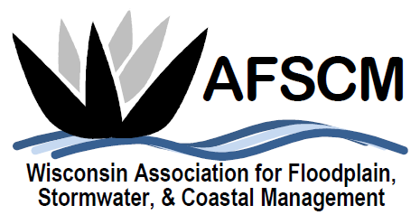

BUSINESS MEETING AGENDA
Thursday, October 20, 2022

- Introduction – Doug Kerns, Chair

- Approval of 2020 Business Meeting Minutes – Virtual Meeting, 11/5/2020

- Approval of 2021 Business Meeting Minutes – La Crosse, WI, 11/4/2021

- Committee Reports
  - Treasurer’s Report – Minal Hahm
  - Annual Conference Committee – Jacob Maas
  - Awards Committee – Laura Herrick
  - Education Committee – Terry Tavera
  - Membership Committee
  - Website Committee – Ryan Van Camp
  - Newsletter Committee – Betsy Powers
  - Scholarship Committee – Heather Thole
  - Legislative Committee – Dave Fowler
  - WDNR Liaison Floodplain Management Committee – Michelle Hase

- 2022 Year in Review & Future Considerations
  - Upcoming Board Meetings – Doug Kerns
  - Future Webinars and Continued Education Opportunities – Terry Tavera
  - Committee Needs – Doug Kerns
  - WAFSCM 2023 Conference, November 1st – 2nd at the Hyatt Regency in Green Bay – Laura Herrick/Doug Kerns

- Other Business

- Next Business Meeting – November 2, 2023

