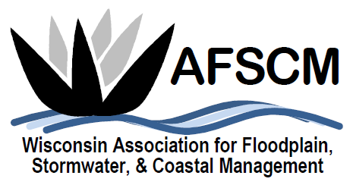

QUARTERLY BOARD MEETING
Monday, March 2, 2020
3:30 pm

LOCATION: Skype Conference Call Number: 469-214-8538
Conference Code: 546-273-801

Agenda

- ATTENDANCE
- APPROVAL OF DECEMBER 3, 2019 BOARD MEETING MINUTES
- treasurer’s report

- 2020 ANNUAL CONFERENCE

- FUTURE ANNUAL CONFERENCES
  - 2021 – Joint Conference with MN in LaCrosse
  - Planning Reference Document
  - 2024 ASFPM Conference in Milwaukee

- COMMITTEE REPORTS
  - Awards Committee – Laura Herrick
  - Education – Terry Tavera
  - Legislative Committee – Dave Fowler
  - Membership – Kristen Belan
  - Newsletter – Betsy Powers
  - Scholarship – Katie Sommers
  - WDNR Liaison Floodplain Management – Michelle Staff
  - Website – Ryan VanCamp

- IAFSM RAPID ASSISTANCE FLOOD TEAM
- ASFPM UPDATE

- STRATEGIC PLANNING UPDATES

- OTHER BUSINESS

