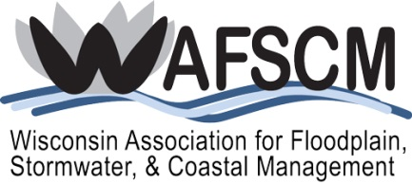
SCHOLARSHIP APPLICATION FORM
for
WAFSCM’S 17th Annual Conference
October 23-25, 2019
Central Wisconsin Convention & Expo Center
Wausau, Wisconsin

STUDENT SCHOLARSHIP FOR ONE DAY ATTENDANCE (October 24, 2019)
You must be a current student to apply for this scholarship!
Name:
School & Major:
Graduation Date:
Address:
City/State/ZIP:
Phone:
Email:

Check which WAFSCM field/activities you are interested in:
Floodplain Management
Stormwater Management
Coastal Management
Interested in starting a student chapter at my school
Other (explain)

How will attending this conference assist you in your future career?

Why do you want to attend this conference and what do you hope to gain by attending?
This scholarship is for a one-day conference attendance (includes break refreshments and lunch). Lodging, travel, and other expenses are not included. If you receive this scholarship, you will be required to write an article for the next WAFSCM newsletter, Water Matters, about your experiences attending the conference or another appropriate subject relating to floodplain, stormwater, or coastal management.

Submit to Katie Sommers, katie.sommers@wisconsin.gov, no later than September 6, 2019.

