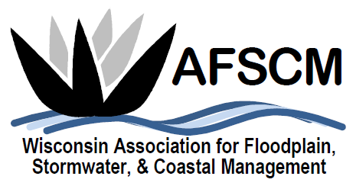
QUARTERLY BOARD MEETING
Tuesday, September 3, 2019 at 3:30 pm

LOCATION: Conference Call Number: 515-739-1460
Conference Code: 534673

AGENDA

- ATTENDANCE
- APPROVAL OF JUNE 4, 2019 BOARD MEETING MINUTES
- TREASURER’S REPORT
- 2019 ANNUAL CONFERENCE
  - Planning Update

- FUTURE ANNUAL CONFERENCES
  - 2021 – Joint Conference with MN in La Crosse?
  - Planning reference document

- Elections held at Annual Conference this Year
  - Open positions and potential nominees

- COMMITTEE REPORTS
  - Awards Committee – Laura Herrick
  - Education – Terry Tavera
  - Legislative Committee – Dave Fowler
  - Membership – Kristen Belan
  - Newsletter – Betsy Powers
  - Scholarship – Katie Sommers
  - WDNR Liaison Floodplain Management – Michelle Staff
  - Website – Ryan VanCamp

- IAFSM RAPID ASSISTANCE FLOOD TEAM
- ASFPM – Katie Sommers
  - Update

- OTHER BUSINESS
  - Board positions for next year

