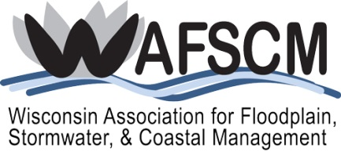
SCHOLARSHIP APPLICATION FORM
for
WAFSCM’S 16th Annual Conference
November 7-9, 2018
Ingleside Hotel
Pewaukee, Wisconsin

You must be a current WAFSCM member or local government official to apply!
Name:
Title:
Employer:
Address:
City/State/ZIP:
Phone:
Email:

Certified Floodplain Manager (CFM): |  | Yes |  | No

Years you have been a WAFSCM member: |  |  |  |  |  |  |  |  |  | 2002 |  | 2003 |  | 2004
 |  | 2005 |  | 2006 |  | 2007 |  | 2008 |  | 2009 |  | 2010 |  | 2011
 |  | 2012 |  | 2013 |  | 2014 |  | 2015 |  | 2016 |  | 2017 |  | 2018

Check which WAFSCM activities you are willing to participate in to support the association:
 | Participate on standing committee(s):
 |  | Floodplain Management |  |  | Annual Conference
 |  | Stormwater Management |  |  | Website
 |  | Coastal Management |  |  | Newsletter
 |  | Membership |  |  | Education
 |  | Awards
 | Provide support in workshops or other training events
 | Other (explain)
Describe any past involvement you have had with WAFSCM:

How will attending this conference assist you in your present position?

Why do you want to attend this conference and what do you hope to gain by attending?

You are responsible for your own transportation and per diem. After attending the conference, you will need to complete a Scholarship Reimbursement Form, attach receipts, and mail to WAFSCM for reimbursement. You will be provided the form upon notification of scholarship award. In addition, you will be required to write an article for the next WAFSCM newsletter, Water Matters, about your experiences attending the conference or another appropriate subject relating to floodplain, stormwater, or coastal management.

Submit to Katie Sommers, katie.sommers@wisconsin.gov, no later than September 21, 2018.

