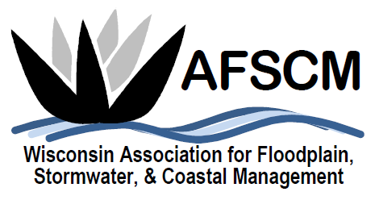

QUARTERLY BOARD MEETING
Tuesday, December 4, 2018
3:30 pm

LOCATION: Conference Call Number: 515-739-1460
Conference Code: 534673

AGENDA

- ATTENDANCE
- APPROVAL OF AUGUST 7, 2018 BOARD MEETING MINUTES
- TREASURER’S REPORT
- 2018 CONFERENCE RECAP

- 2019 ANNUAL CONFERENCE
  - PLANNING COMMITTEE & BOARD ATTENDANCE
  - VOLUNTEERS
  - DO WE WANT TO BUY PROJECTORS
  - SCHOLARSHIPS (SEE 4 ATTACHMENTS)
  - OTHER?

- FUTURE ANNUAL CONFERENCES
  - PLANNING REFERENCE DOCUMENT – CINDI AVAILABLE TO REVIEW
  - UPDATE ON POSSIBLE JOINT CONFERENCES – APA or MNAFPM

- COMMITTEE REPORTS
  - Awards Committee – Laura Herrick
  - Education – Open
  - Legislative Committee – Dave Fowler
  - Membership – Kristen Belan
  - Newsletter – Betsy Powers
  - Scholarship – Katie Sommers
  - WDNR Liaison Floodplain Management – Michelle Staff
  - Website – Ryan VanCamp

- ATTENDANCE AT WISCONSIN CHAPTER OF THE SOIL AND WATER CONSERVATION SOCIETY ANNUAL CONFERENCE – JANUARY 25, 2019, TOMAH, WI

- 2019 WEBINAR IDEAS

- SOCIAL/NETWORKING ACTIVITY PLANNING

- IAFSM RAPID ASSISTANCE FLOOD TEAM
- ASFPM UPDATE
- STRATEGIC PLANNING UPDATES
  - Board job descriptions
  - Google drive usage & access
- OTHER BUSINESS

